**APPLICATION TO INFORMATION AND COMMUNICATION TECHNOLOGY**

LAB

**LAB NUMBER #1**

**SUBMITTED BY:** Fida Hussain

**SUBMITTED TO:** Sir. Faheem Shaukat

**STUDENT ID:** 43307

**DATE:** November 1st, 2024

|  |  |  |
| --- | --- | --- |
| **ID** | **NAME** | **CONTACT** |
| **1** | **ABC** | **1245** |
| **2** | **XYZ** | **5678** |



Multilayer tiME synchronization in IoT

Contents

CHAPTER 1 5

Introduction: 6

Related Work / Literature Review 8

# CHAPTER 1

# Introduction:

IoT (Internet of Things) is a technology that enables every hardware or object to connect and communicate with each other which results in the making network of networks of autonomous devices having fewer computational resources. It also ensures a better quality of services to the users in an unbelievable manner and resolves diverse problems. Devices could be from any group of wireless routers, smarts phones, MiFi devices, embedded sensing and reporting devices, smart motors, etc. Smart metering, smart houses, and tele medicines are a few renowned examples of IoT. IoT is not a solo technology, rather many technologies workcollaboratively andsystematically to provide an interface with the physical world to access, process, and store sensors data appropriately to take decisions accordingly[1].

IoT term was used by Kevin Ashton in 1999 for the first time while working at the Auto-ID center to make a small network of RFID (Radio-frequency Identification) devices. At present, enormous devices are communicating which each other than the total population on earth. According to the Gartner Inc, assessment in 2017, the Internet of Things (IoT) will add20.4 billion operational devices by 2020 [2]with an investment of three trillion dollars.

Many issues and challenges need to be catered to while considering the exponential growth in IoT and the development of allied applications for it. The connectivity of allsort of devices in IoT, their diverse nature, and the huge volume of devices comes into mind. Therefore, a unique methodology is required to be sorted out for IoT implementation. Other big challenges in IoT are the interoperability and compatibility of all multi-purpose devices. These small devices must communicate systematically. Time synchronization is one of the most important parameters for the development of applications in IoT. A variety of several protocols have already been developed for many applications but now a unique protocol for timing synchronization is the requirement. QoS parameters like security, including confidentiality and integrity of data, must be considered prime focus because anyone can access wireless transmission and control devices and alter the information. So, it is crucial to ensure that authentic users get the data and that user information must not be revealed to any unauthorized user in the network. Otherwise, the security of the network will be compromised and the network will be vulnerable to attacks.

The other parameter which needs to be focused on is scalability. As connected devices number is expanding drastically. During the development of routing protocols and the technique for centralized or distributed data storage, scalability must be taken care of. Otherwise, desired functionality cannot be achieved. In IoT, devices are small, have less power consumption, and have the limited computational capability, making energy efficiency an important factor during the development. A designer should also use a sophisticated routing protocol that can help to easily communicate a large number of small devices without congestion or loss of any valuable information. Among all the researchcarried out in all aspects of IoT, time synchronization is a special one because interoperability and updating of events of various devices can be attained through it. By using this, a detailed analysis can be performed after collecting the necessary information. Time synchronization has become a challenging mission for researchers and developers for small devices networks which have less power consumption.

In any wireless or wired network of devices, there are three types of time synchronization frameworks available and these frameworks have theirtime synchronization procedures. These frameworks include Master-Slave, Peer-Peer, and distributed [3]. At the physical layer, the symbol timing synchronization method is used to extract the time offset for synchronization.

CHAPTER 2

# Related Work / Literature Review

* IoT system-level architecture
* IoT architecture can be distributed into three major tiers
* Devices Tier
* 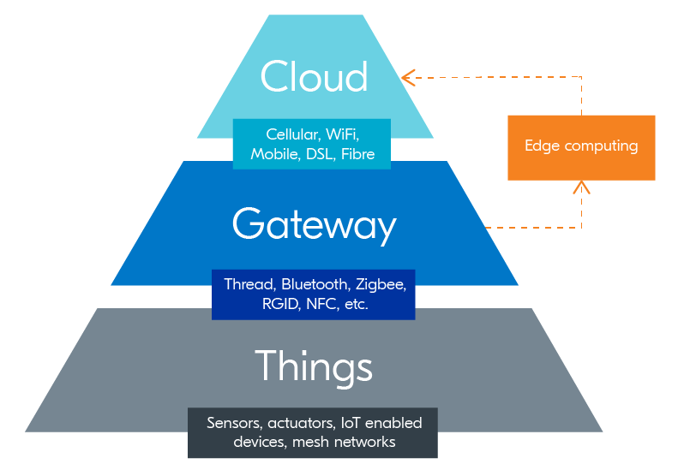Edge Gateway Tier

Figure 0.1 Basic IoT Architecture

* Cloud Tie